**Online Diary**

Our main task was to create a game which would demonstrate employability skills. I was assigned to a team of people who I did not know, this was a good thing as it helped me get to know individuals who would have never had a chance to get to know otherwise. Working as a team we able to come up with different ideas and concepts; we ended up using an existing game called sheriff of Nottingham as a reference point as we wanted to transfer the skills needed to play that game into out game.

My main worry after deciding what the game was, how we were all going to make one PowerPoint about our game as we were all working online; Danyal suggested google slides and you no what that really was the saving grace in this project. Thinking back there was one thing we should have changed, the title of the game.

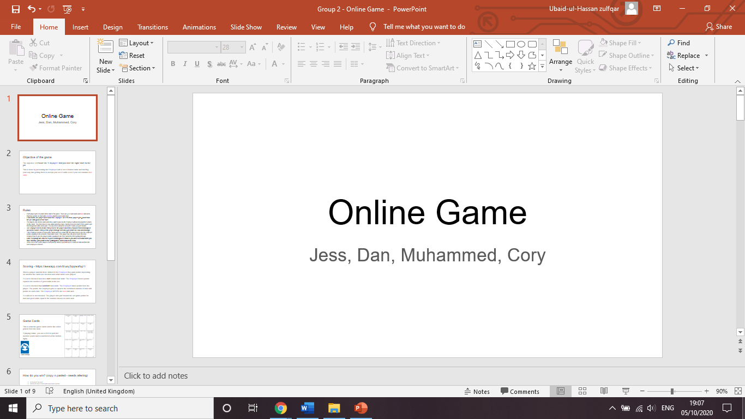

We split of into out little roles. Danyal’s was in charge of writing what the game was, Jess’s role was writing the rules, Cory’s role was to add any miscellaneous information like the scoring system and finally my role was to check to make sure that each sentence made sense and change it accordingly.

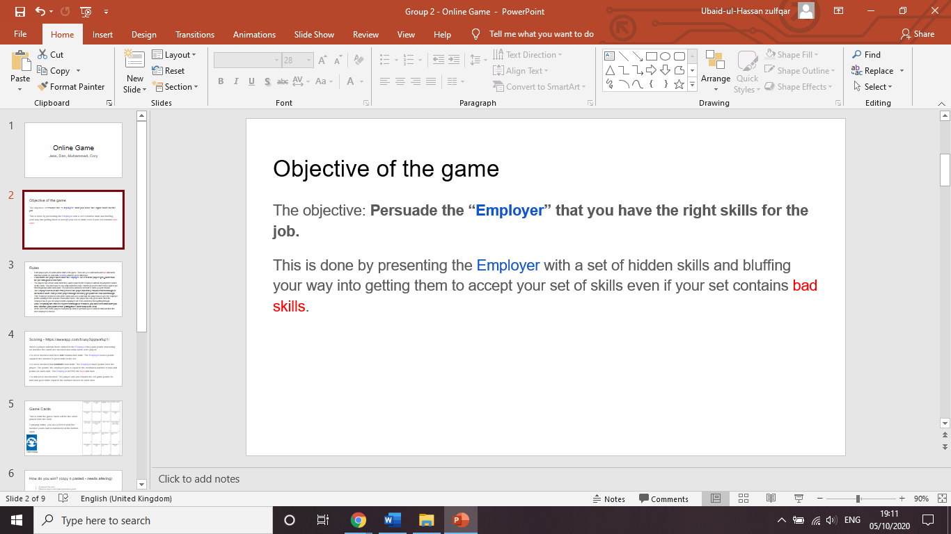

Since the main objective of our task was to demonstrate employability skills within games, we had to demonstrate how our game did this. Employers want people who are confident in communicating ideas. In our first slide we talk about how the player must present themselves to an employer even if they do not have the right skills.

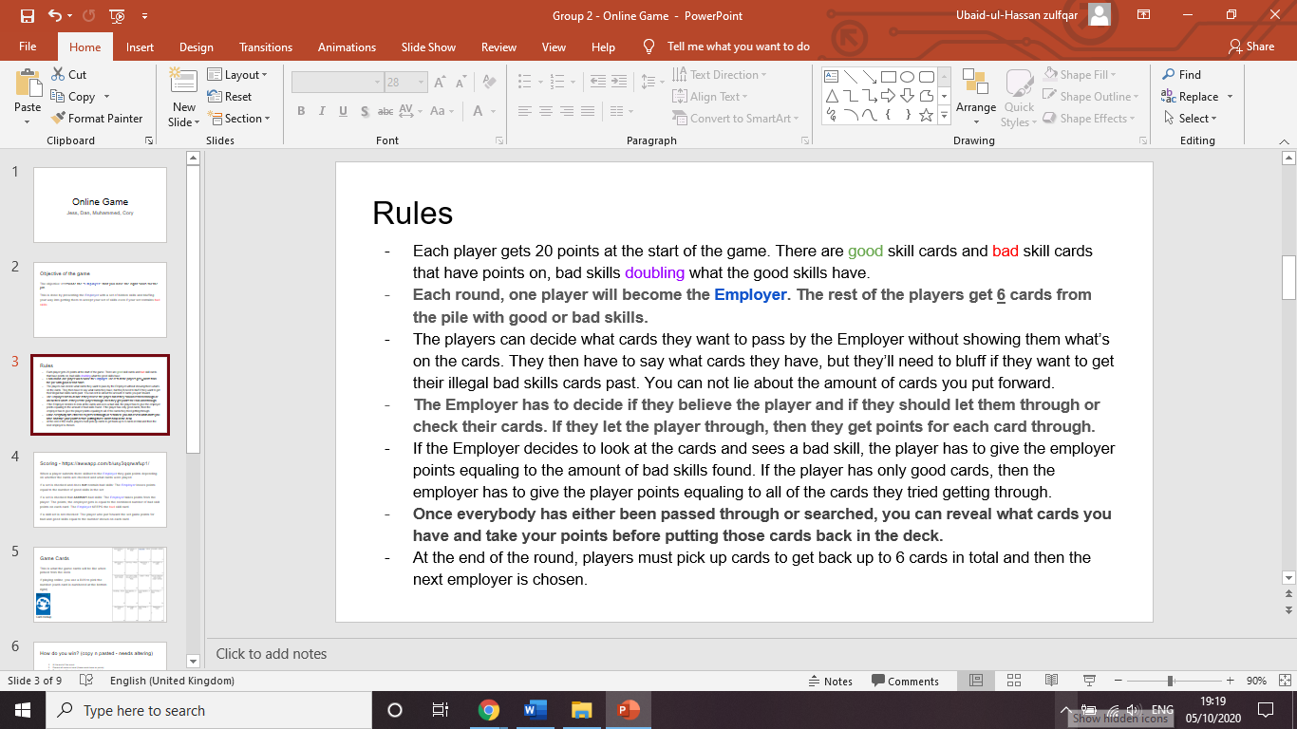

Rules are important in games as if people do not know them there won’t be a fair game at all. As you can see the rules are quite large in size and look intimidating to new players. I take full blame for this as my role was to go back and read the presentation and make changes, I did bring up the point but did not make any changes to it, I should have made a few changes. That being said most of our rules talk about how to present and persuade people to win.

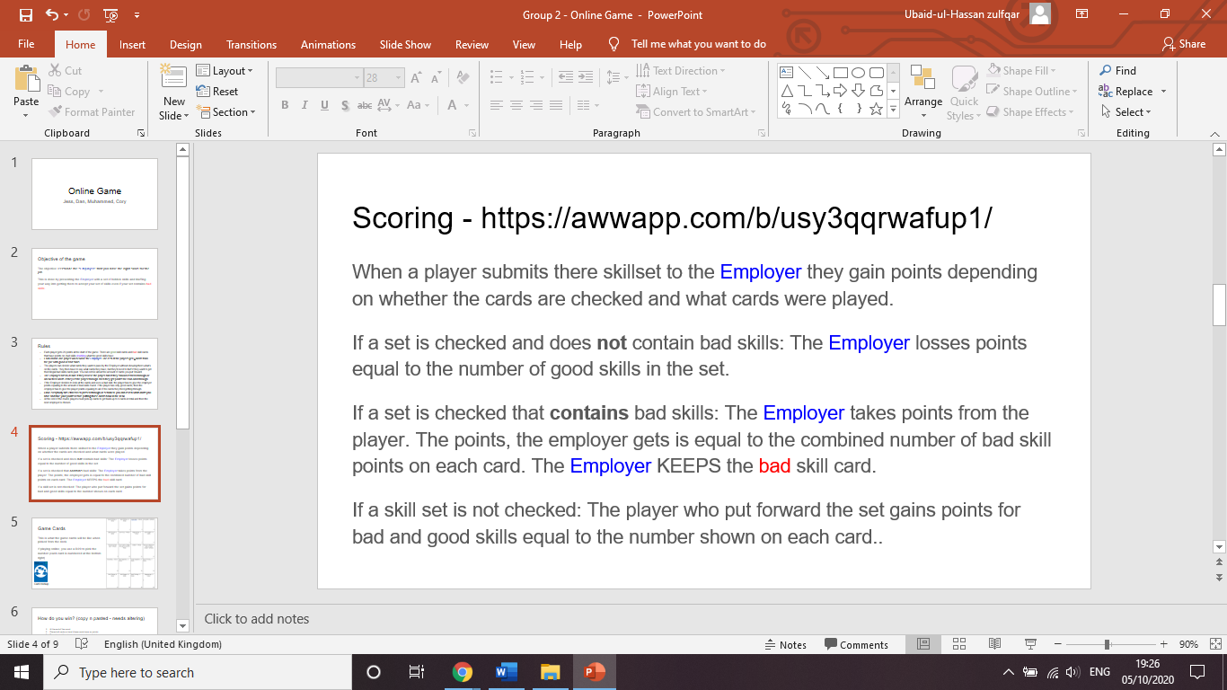

At the top of this page there is a page to online whiteboard that allows other groups to test the game with us. Scoring was done by Cory, that being said I made a few changes as words and phrases were missed out after he had finished. For example, where it says the “if a set is checked and dies not contain bad skills”, this sentence used to be “set checked contain bad skill”. Another place where I made a few changes was “the employer takes points from the player”, this used to “the employer takes the bad skill and combined points of the good and bad”.

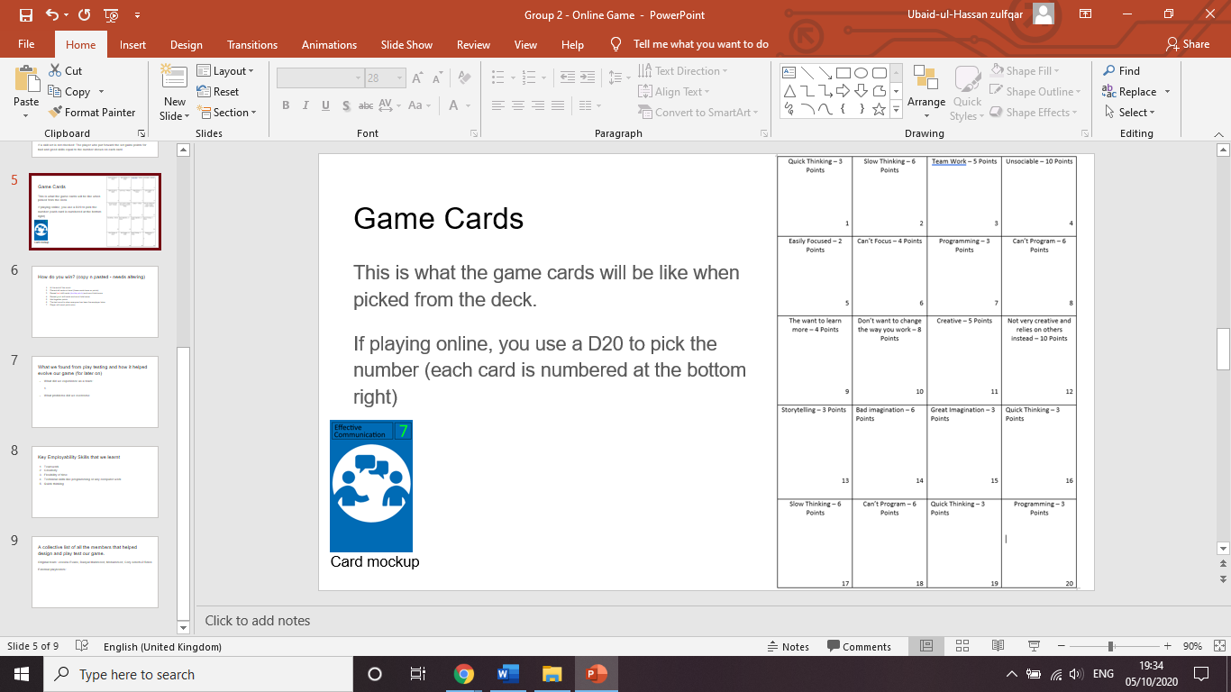

Game cards are essential in this game as the whole concept is for you to present you skill to your employer in a good way. This page was done the whole team. It was done on a grid in PowerPoint and we used textboxes to add the test.

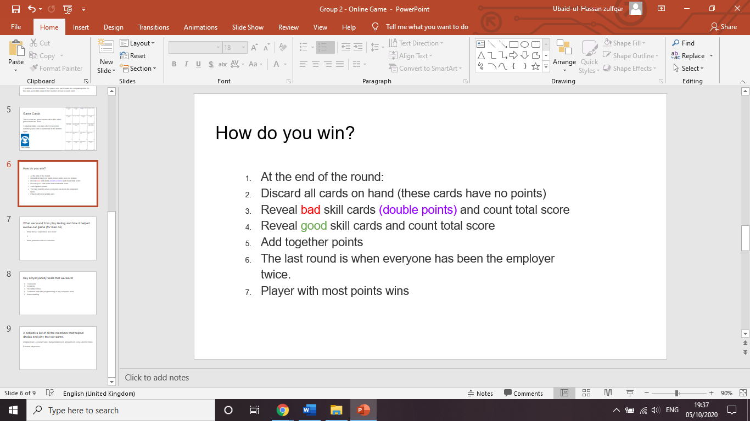

In the rules and scoring page it does not mention anywhere how a player wins overall. I brought this point up and we able to make a new slide explaining how a player wins the whole game. Players finish the game once every player has been the player has been the employer twice. After that the points are added and overall winner is crowned.

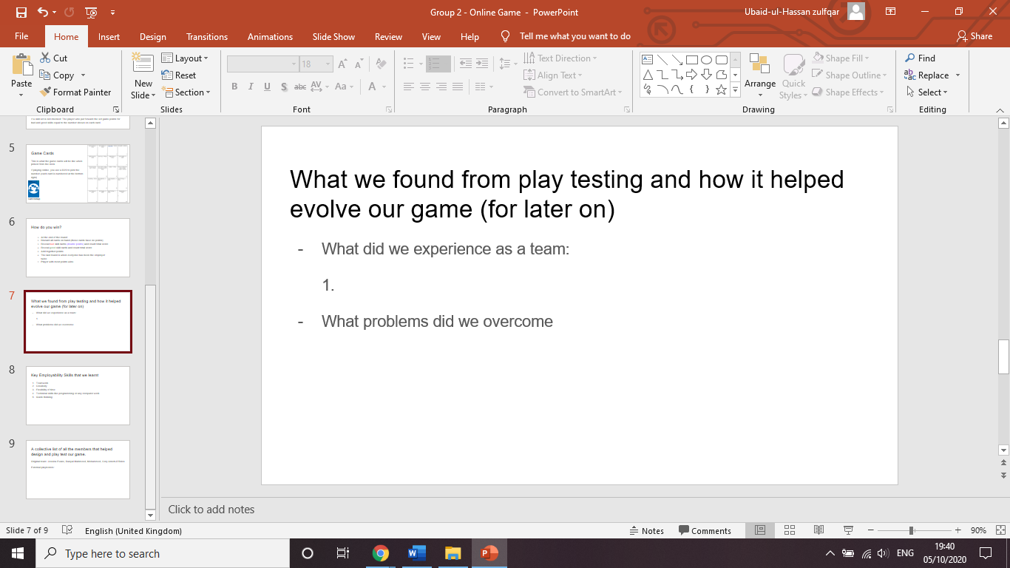

Unfortunately, we did not have enough time to do any play testing as we did not use our time wisely. This is another point we need to keep in mind for next time. Overall the things I need to keep in mind for next time is make sure to reference sources, shorten long paragraphs and use time wisely.

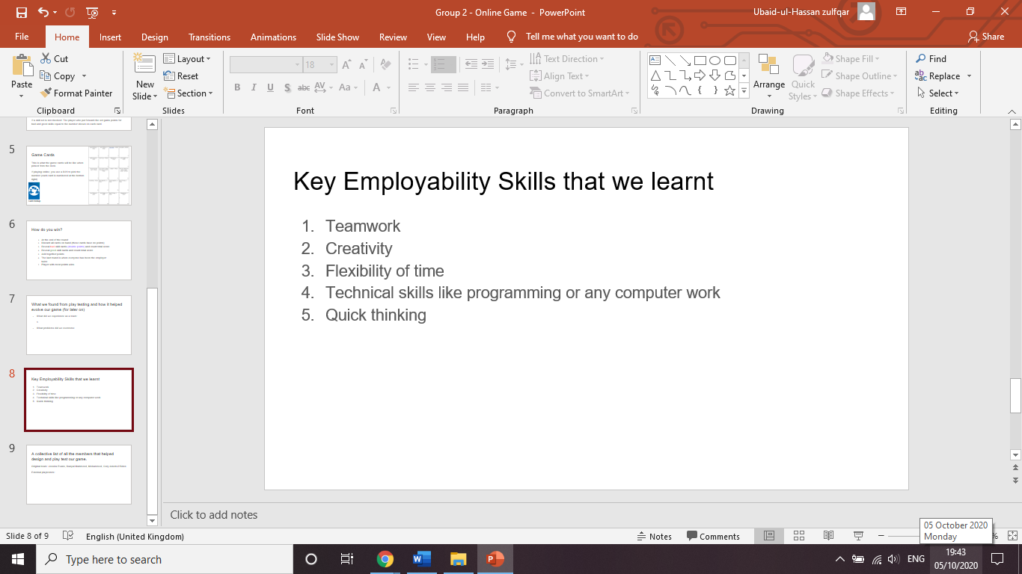

At the end we came back together and listed a few team skills we had learnt or discovered during this task that would interest employers. I would like to add a few more in the future and expand my skill set even further to look even more appealing to an employer.

Overall, I enjoyed working as a team and I was really happy that my teammates were quite willing people and did push not push their work on to other people. I will make sure to have my mic fixed for next time as I would really like to present in front of the class, I would also like be able to add more contribution to my team and make improvements based on feedback given to me.